Explanation Module: EduGenie utilizes the LaMini-Flan-T5 model, a lightweight yet powerful generative AI, to deliver educational content in a simplified and highly readable manner. This model is specifically fine-tuned to provide concise, context-aware responses that break down complex topics into easily understandable language. By focusing on clarity and brevity, EduGenie ensures that learners with minimal background knowledge or technical experience can grasp essential concepts without feeling overwhelmed. This makes it particularly valuable for beginners, school students, or self-learners seeking straightforward explanations. The integration of LaMini-Flan-T5 empowers EduGenie to act as a reliable and accessible study companion for foundational learning across subjects.

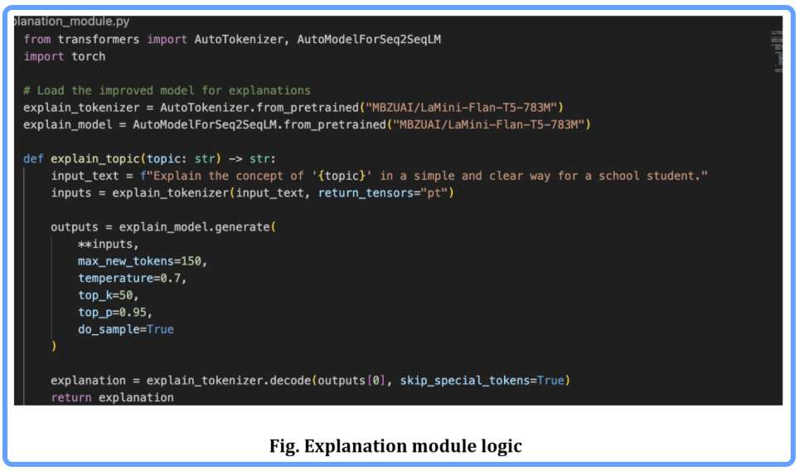
QnA Module: EduGenie is powered by Gemini 1.5 Pro, enabling it to handle a wide range of general knowledge and academic question-answering tasks with precision. Its advanced understanding and contextual capabilities make it an effective tool for learners seeking accurate, AI-driven assistance across diverse educational topics and subjects.

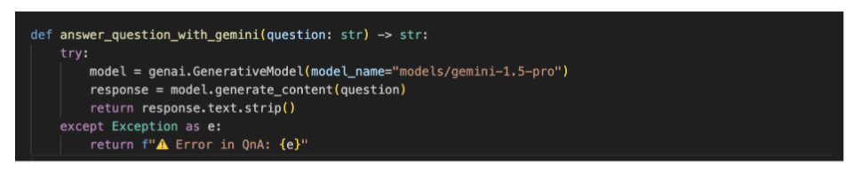
Quiz Module: EduGenie generates three multiple-choice questions (MCQs) from a given passage, each containing four carefully crafted options. It utilizes the Gemini model to comprehend the context and meaning of the passage, ensuring that the questions are relevant and the distractors are plausible. The final output is structured in JSON format for easy integration.
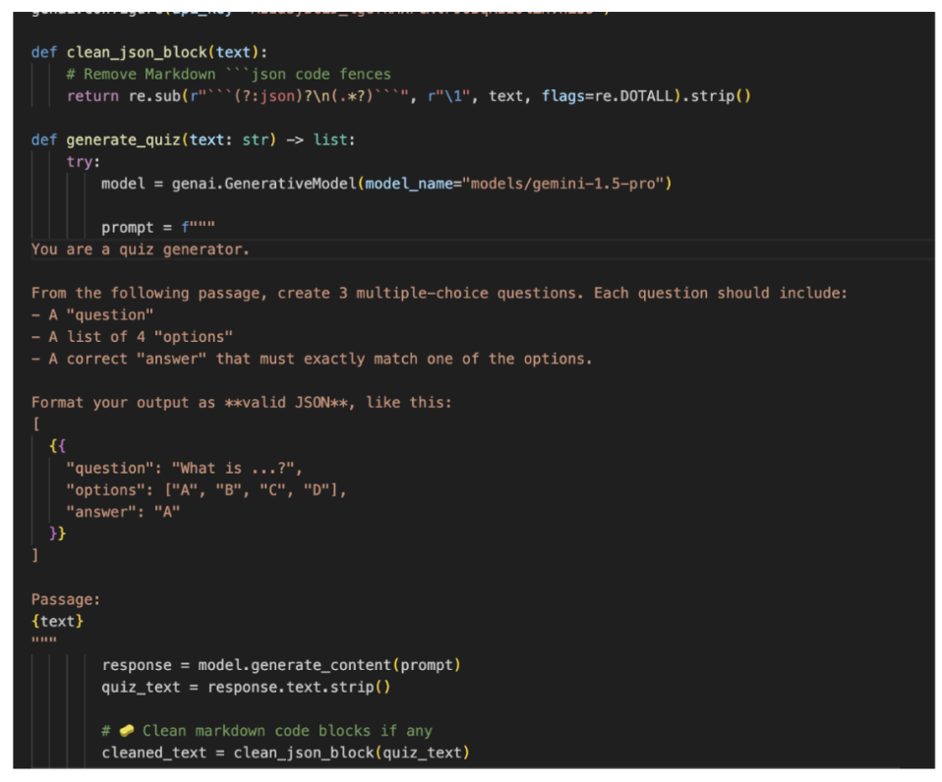
It sends a structured prompt to the model, expecting a valid JSON response with each question containing four options and a correct answer. To ensure proper parsing, it cleans any Markdown code blocks using the clean_json_blockfunction. The cleaned response is then parsed into a Python list. If an error occurs during generation or parsing, it returns a detailed error message for debugging.
Summary Module: This feature leverages Gemini’s generative capabilities to summarize long paragraphs into concise, easy-to-understand versions, making it ideal for quick revision. It ensures the core information is retained while eliminating redundancy, helping learners absorb key points efficiently without losing clarity or context.
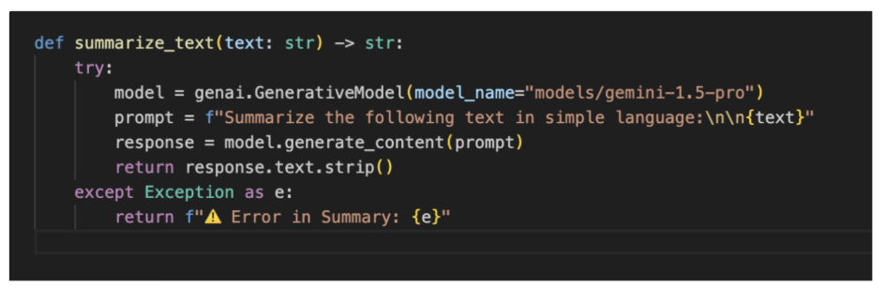
Learning Path Module: The get_learning_recommendations function uses Google Gemini to generate a personalized, structured learning path for any given topic. Crafting a detailed prompt, it instructs the AI to suggest beginner to advanced concepts, organized by difficulty, and supported with useful resources such as videos, articles, or books. It ensures adaptability to the learner’s level. The function safely handles API responses and errors, providing either the generated text or a helpful error message if the response is invalid or incomplete.

